Add Oracle 10g XE Database into Visual C#.NET

In this section we discuss how to add an Oracle 10g XE database into Visual C#.NET applications using the Design Tools and Wizards - Data Source windows.
Before we can perform this database addition, a sample oracle database CSE_DEPT should have been created with a user account named CSE_DEPT. Refer to section 2.11 in Chapter 2 and Appendix D to get more detailed information in how to create a new user and the associated customer database.
In the following section, we use a sample project OracleInsertWizard we developed in Chapter 6 to illustrate how to add an oracle 10g XE customer database into this Visual C#.NET application using the Data Source tools.
Open the project OracleInsertWizard and the Data Source window, and then click the link Add New Data Source to open the Data Source Configuration Wizard. Keep the default selection Database unchanged and click the Next button to go to the next window.
On the next window, click the New Connection button since we need to create a new connection to our sample database CSE_DEPT. On the opened Add Connection dialog, which is shown in Figure E-1, click the Change button that is located at the right of the Data source textbox to open the Data Source list. Select the Oracle Database item from the list and click the OK button. Enter our Oracle server name XE into the Server name box, and enter CSE_DEPT and reback into the Username and Password boxes, respectively. Your finished Add Connection dialog box should match one that is shown in Figure E-1.

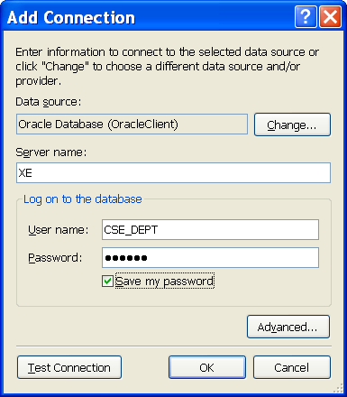

Figure E-1. The Add Connection dialog box

You can click the Save my password checkbox if you like, and then click the Test Connection button to test this connection. A Connection Success message box will be displayed if this connection is fine.
Then click the OK button to go to the next window, which is shown in Figure E-2.
Keep the default data source XE.CSE_DEPT unchanged and click Yes radio button to include the whole connection information in the connection string. You can also expand the Connection String by clicking the plus sign before it to see the content of this
connection string, which shown in Figure E-2.

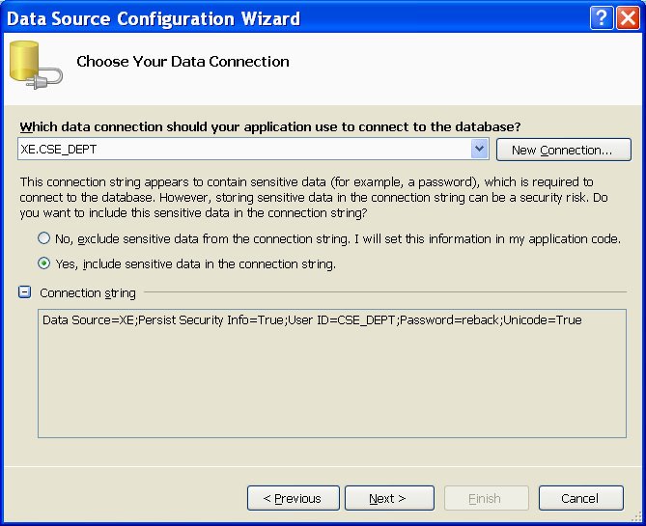

Figure E-2. Data connection dialog

Click the Next button to go to the next window.
In the next window, you are prompted to save this connection string into your configure file in your application. It is a good habit to integrate all staff together to form a complete project. Therefore click Yes to it and modify the name of the connection string to OracleXEConnString, which is shown in Figure E-3.

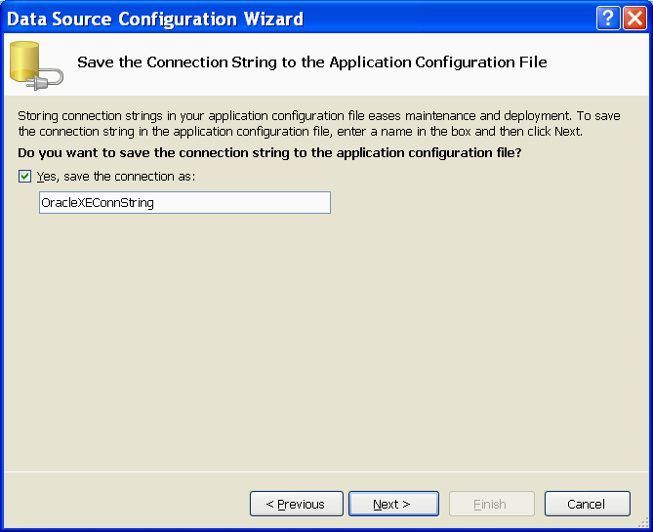

Figure E-3. Modify the name of the connection string

Click the Next button to go to the next window.
In the opened next window, first change the DataSet name to CSE_DEPTDataSet and then expand the Tables object to list all tables available to our application, which is
shown in Figure E-4.

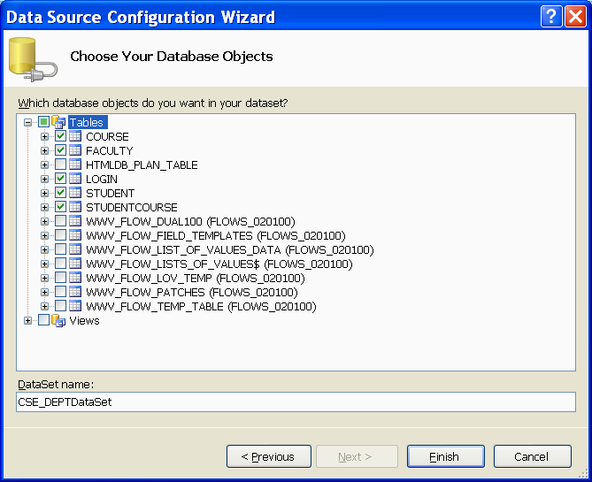

Figure E-4. Select desired data Tables and Views

We only have interests in those five tables we created and they are related to our application. Select those five tables by checking them one by one, which is shown in Figure E-4. Your finished Table Selection window should match one that is shown in Figure E-4. Click the Finish button to complete this database addition process.

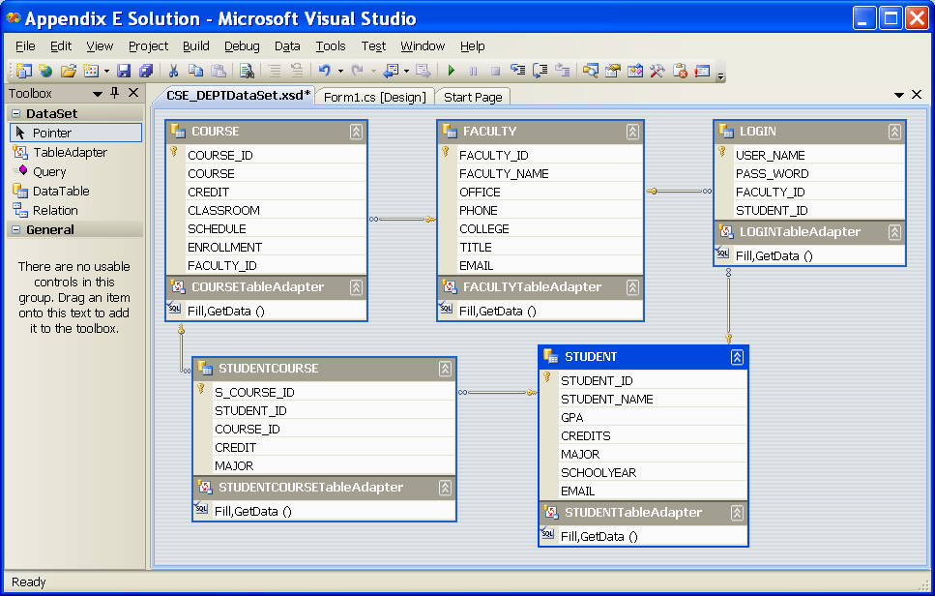
Figure E-5. The added five tables

Immediately you can find that five selected tables have been added into the Data Source window. Right click on any place inside the Data Source window and select Edit DataSet with Designer item from the popup menu to open the DataSet Designer window, which is shown in Figure E-5. You can find all five tables and their relationships between them from this Designer window.

